**ASSESSMENT 06**

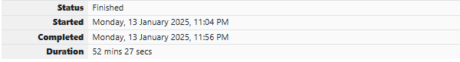

**CODING**

**QUESTION 1**

You are given a sequence of n-1 distinct positive integers, all of which are less than or equal to a integer ‘n’. You have to find the integer that is missing from the range [1,2, . . . n]. Solve the question without using arrays.

Input Format:

One line containing the integer ‘n’ where 2<=n<=10,000

First line is followed by a sequence of ‘n-1’ distinct positive integers. Note that the sequence may not be in any particular order.

Output Format:

One line containing the missing number

Sample Test Cases

Test Case 1

Input

3

1 2

Output

3

Test Case 2

Input

4

1 3 4

Output

2

**For example:**

| **Input** | **Result** |
| --- | --- |
| 3  1 2 | 3 |
| 4  1 3 4 | 2 |

**SOURCE CODE**

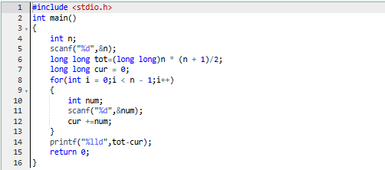

**OUTPUT**

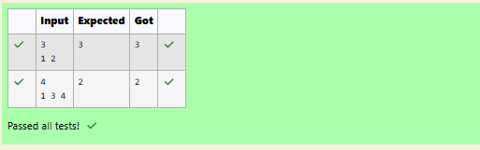

**QUESTION 2**

A Teacher came to the class with a large box that has several coins. Each coin has a number Printed on it. Before Coming to the class, she ensured that all the coins occurs an even number of times. However, while coming to the class one coin fell down and got lost. She wants to find out the number of missing coin (Solve the question without using arrays).

Input Format:

Take Number from stdin which no of coins n.

Take n-1 array of Integers from stdin.

Output Format:

Print the number of coin which is missed.

Example Input:

8

5 7 2 7 5 2 5

Output:

5

**For example:**

| **Input** | **Result** |
| --- | --- |
| 8  5 7 2 7 5 2 5 | 5 |
| 6  5 5 6 6 6 | 6 |

**SOURCE CODE**

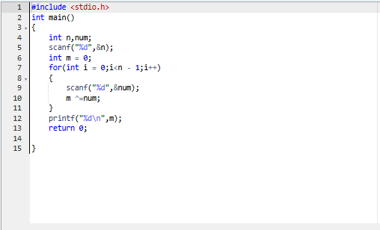

**OUTPUT**



**QUESTION 3**

An abundant number is a number for which the sum of its proper divisors is greater than the number itself.

Proper divisors of the number are those that are strictly lesser than the number.

Input Format:

Take input an integer from stdin

Output Format:

Print Yes if given number is Abundant. Otherwise, print No

Example input:

12

Output:

Yes

Explanation

The proper divisors of 12 are: 1, 2, 3, 4, 6, whose sum is 1 + 2 + 3 + 4 + 6 = 16. Since sum of proper divisors is greater than the given number, 12 is an abundant number.

Example input:

13

Output:

No

Explanation

The proper divisors of 13 is: 1, whose sum is 1. Since sum of proper divisors is not greater than the given number, 13 is not an abundant number.

**For example:**

| **Input** | **Result** |
| --- | --- |
| 12 | Yes |
| 13 | No |

**SOURCE CODE**

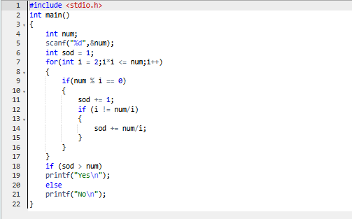

**OUTPUT**

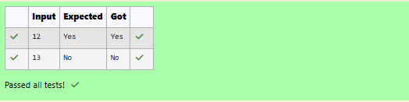

**LINEAR SEARCH**



Sample Input 1:

5

30 40 50 20 10

20

Sample Output 1:

Element found at location : 3

Sample Input 2:

5

30 40 50 20 10

55

Sample Output 2:

Element not found.

**SOURCE CODE**

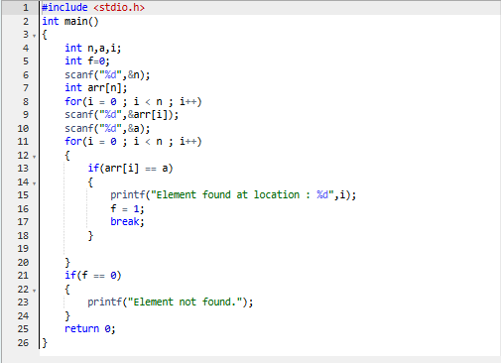

**OUTPUT**

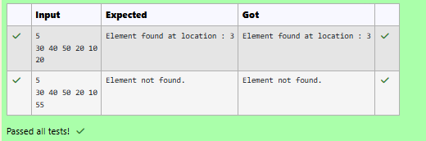

**BINARY SEARCH**

Sample Input 1:

5

10 20 30 40 50

30

Sample Output 1:

Element found at location : 2

Sample Input 2:

5

10 20 30 40 50

55

Sample Output 2:

Element not found.

**For example:**

| **Input** | **Result** |
| --- | --- |
| 5  10 20 30 40 50  30 | Element found at location : 2 |
| 5  10 20 30 40 50  55 | Element not found. |

**SOURCE CODE**

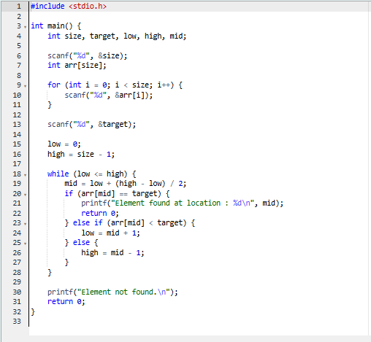

**OUTPUT**

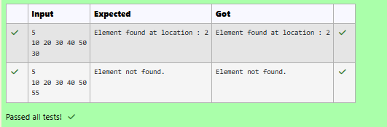

**INSERTION SORT**



Sample Input:

5  
30 40 50 20 10

Sample Output:

10 20 30 40 50

**For example:**

| **Input** | **Result** |
| --- | --- |
| 5  30 40 50 20 10 | 10 20 30 40 50 |

**SOURCE CODE**

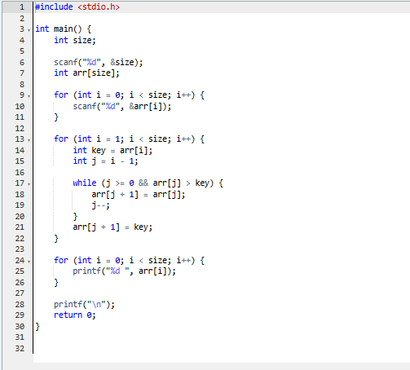

**OUTPUT**



**SELECTION SORT**

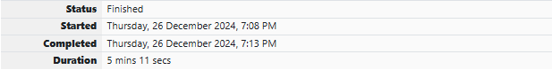

Sample Input:

5  
30 40 50 20 10

Sample Output:

10 20 30 40 50

**For example:**

| **Input** | **Result** |
| --- | --- |
| 5  30 40 50 20 10 | 10 20 30 40 50 |

**SOURCE CODE**

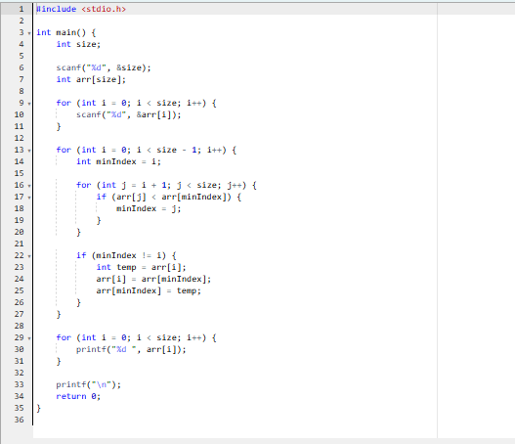

**OUTPUT**

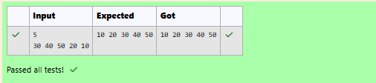

**BUBBLE SORT**

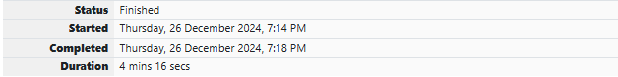

Sample Input:

5  
30 40 50 20 10

Sample Output:

10 20 30 40 50

**For example:**

| **Input** | **Result** |
| --- | --- |
| 5  30 40 50 20 10 | 10 20 30 40 50 |

**SOURCE CODE**

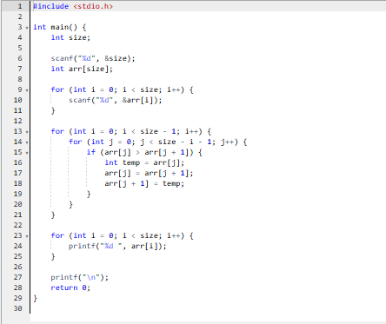

**OUTPUT**

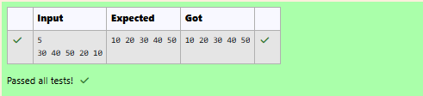

**QUICK SORT**

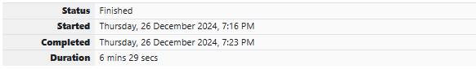

Sample Input:

5  
30 40 50 20 10

Sample Output:

10 20 30 40 50

**For example:**

| **Input** | **Result** |
| --- | --- |
| 5  30 40 50 20 10 | 10 20 30 40 50 |

**SOURCE CODE**

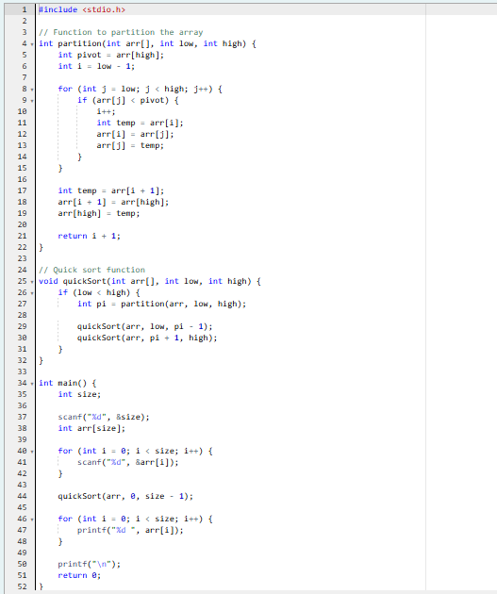

**OUTPUT**

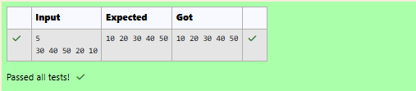

**MERGE SORT**



Sample Input:

5  
30 40 50 20 10

Sample Output:

10 20 30 40 50

**For example:**

| **Input** | **Result** |
| --- | --- |
| 5  30 40 50 20 10 | 10 20 30 40 50 |

**SOURCE CODE**

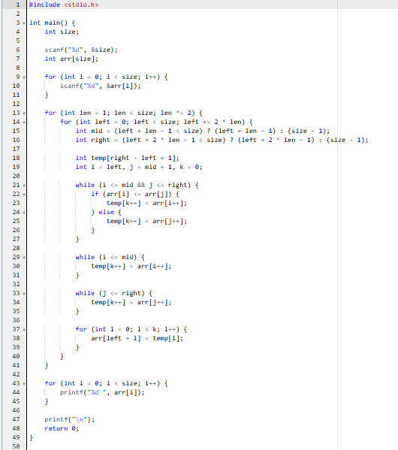

**OUTPUT**

